Chapter 14, Solution 44.

Consider the circuit below.
R₂
jL
1/jC
Z_{in}
R₁

- 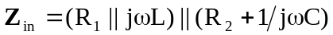

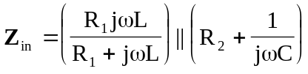
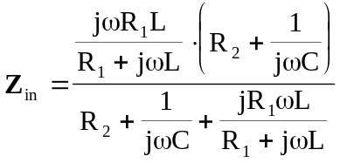
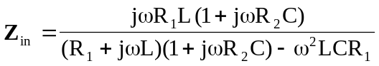
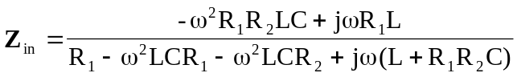
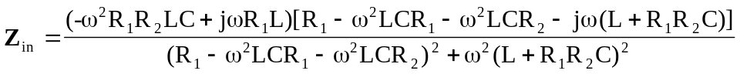

At resonance, 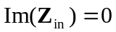, i.e.
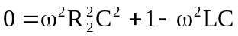
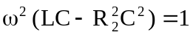

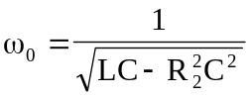
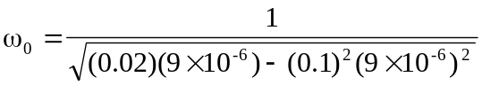
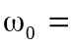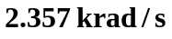

- At 

